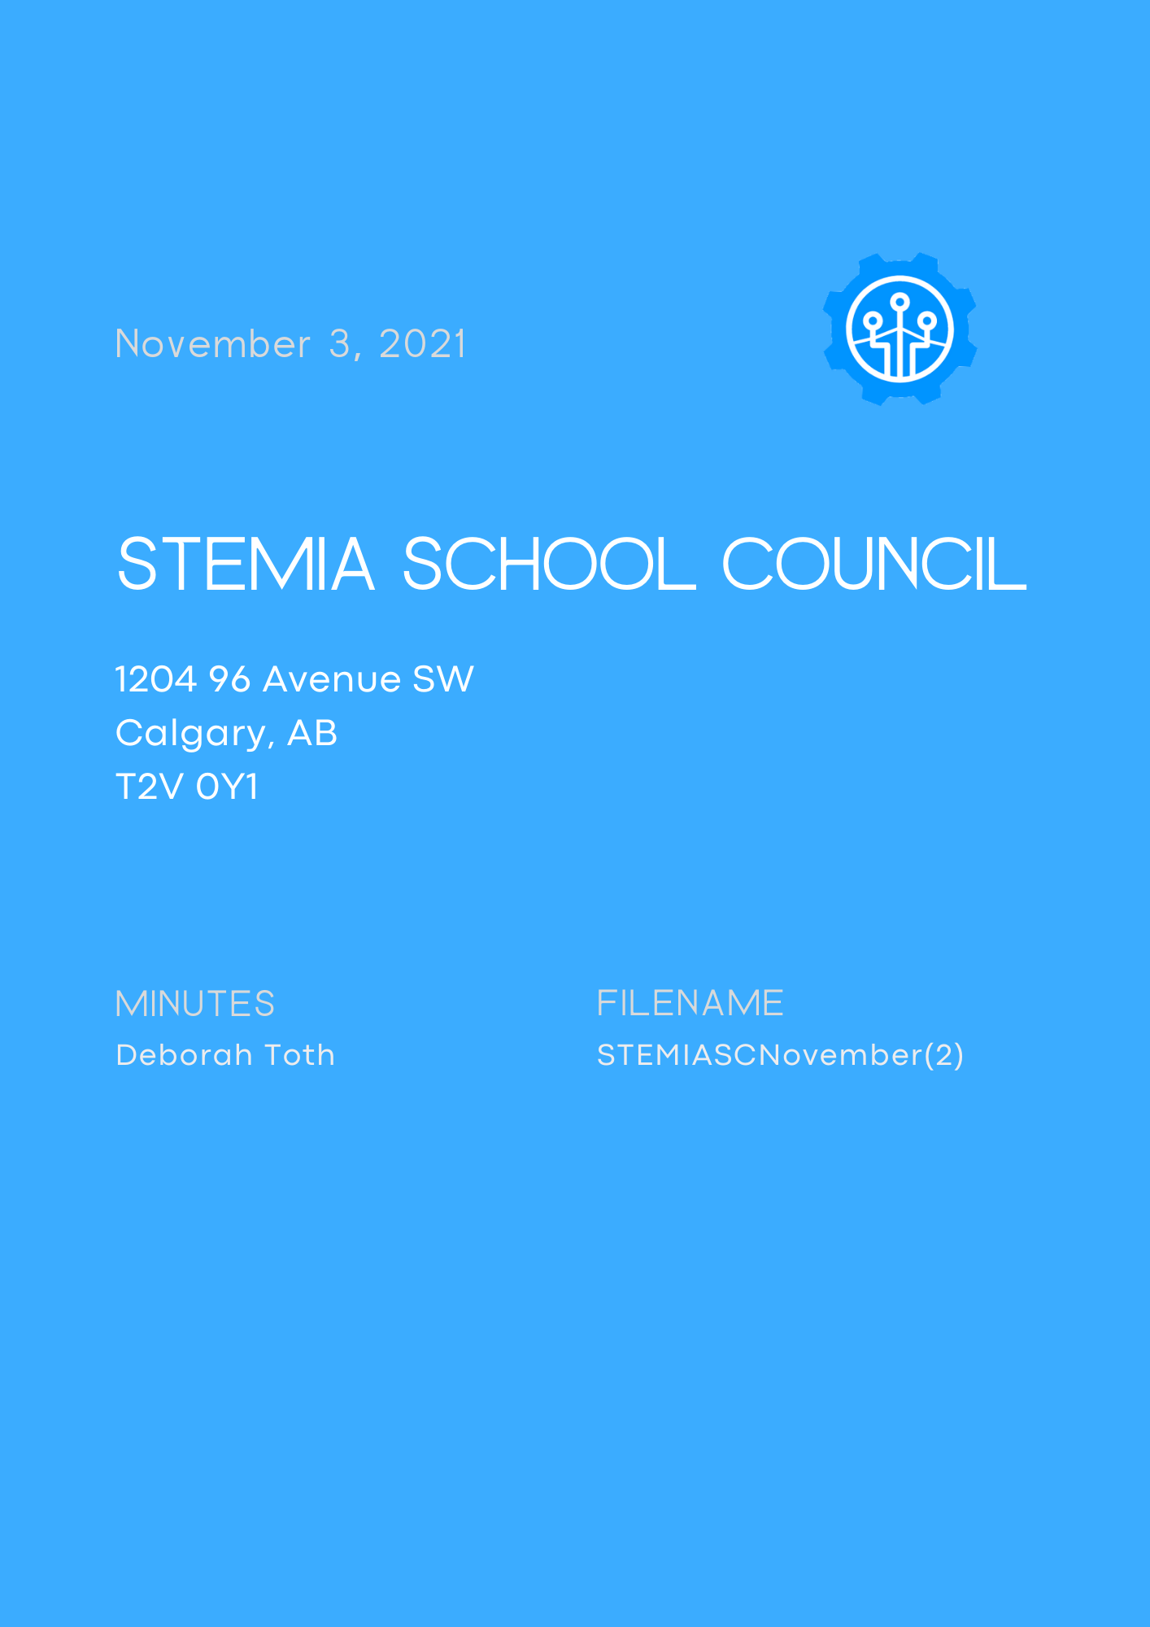

|  |
| --- |
|  |

# DATE/ TIME

November 3, 2021/ 6.30 PM via ZOOM

# FACILITATORS

STEMIA School Council Executive Committee

# ATTENDEES

**EXECUTIVE COMMITTEE**

Golden (Gurmeet) Bhatia (Chairperson)

Shawn Furlong (Vice-Chairperson)

Deborah Toth (Secretary)

**SCHOOL STAFF/ ADMINISTRATION**

Kerry Blum (School Principal)

Caitlin Gillie (Teacher Representative)

**GUEST SPEAKERS**

Lisa Davis (Co-Founder, COO/ Secretary-Treasurer of STEM IA Society)

Joanne Higgins (School Superintendent)

**PARENTS**

Angela B., Amanda P., Bernette H., Justin A., Josephin J., Trish W., Heather R., Tammy K., Heather F., Amber M., Henny B., Zaheer S., Rebecca O., Napapan W., Sara S., Nisha I., KaeLeah S., Cat K.

# call to order

Quorum declared to be present and meeting **called to order at 6.35 PM** by Golden Bhatia.

# WELCOME AND INTRODUCTIONS

**WELCOME**

Golden Bhatia introduced the members of the Executive Committee and gave a Land Acknowledgement.

# Approval of agenda and minutes

**APPROVAL OF AGENDA (Golden B./ Shawn F.)**

Agenda was unanimously approved as distributed.

**APPROVAL OF MINUTES OF OCTOBER 4, 2021 (Deb T./ Shawn F.)**

The Minutes from the previous council meeting with Lisa Cormier serving as Secretary were sent via email to all parents of STEM IA on October 27, 2021. The Minutes were unanimously approved as distributed.

# GUEST SPEAKERS

**LISA DAVIS**

**JOANNE HIGGINS**

# REPORTS

**CHAIR REPORT- Golden Bhatia**

**Double Click on icon to view Golden Bhatia’s Chair Report**

**Alberta School Council Association**

The Executive Committee has completed the registration of the STEMIA School Council with the Alberta School Council Association (ASCA) and will discuss the possibility of getting a membership.

**Bylaws and Procedures**

Our Bylaws and Procedures for the STEMIA School Council were sent on October 27, 2021. The Executive Members and the School Principal worked together to agree on AGM dates and appropriate terms of office for elected members of the Executive Board.

**Alberta School Council Engagement Grant**

We filled out an application to be considered for the Alberta Government CAD $500.00 Engagement Grant. STEM IA’s Secretary-Treasurer, Lisa Davis, signed the form and it was sent off on October 29, 2021.

**Meetings**

Golden shared that our Executive Committee reached an agreement with Kerry Blum regarding our monthly meetings. It was decided that our STEMIA School Council will be held on the first Wednesday of each month.

**Volunteer Link**

A google form was sent to all parents to gauge interest for various council positions and committees. Golden shared that there was significant interest from a relatively good number of parents who also had some great suggestions.

The volunteer link was posted in the chat:

<https://docs.google.com/forms/d/e/1FAIpQLSes8l1GmLnLeZ06mh1gdJuQiSYihH4FWFCxs0t-fmq1eQokvA/viewform>

**Parent-Interview Meals and Gift from CO-OP**

In early October, the Executive Committee reached out to local community partners to help with a meal for our STEM IA Teachers. MacLeod Trail CO-OP generously donated a CAD $150.00 gift card to help with some sandwiches, veggies, and desserts.

Golden shared pictures of the event and thanked the STEM IA teachers for their hard work during the Parent-Teacher interviews.



Double click on icon to view pictures

**Website**

Golden informed members of council that our Executive Committee is currently working on a website. The website will be home to our council minutes and will also feature community partners who have supported the STEMIA School Council. Other things that will be accessible on the website will include: a section for volunteer opportunities; helpful resources and links for parents; and Treasurer budgets and reports.

**AHS Link**

Wendy Eloit from AHS’s Community Education Service Department, was recently introduced to our Executive Committee. There are currently free live webinars or pre-recorded sessions that tackle subjects such as bullying, mental health, anxiety, and learning disorders. These sessions are incredibly helpful and Golden encouraged parents to visit their website for more information.

Community Education Service (CES) Free Live Webinars and Sessions: <http://community.hmhc.ca/>

**PRINCIPAL AND TEACHER REPRESENTATIVE REPORT- Kerry Blum and Caitlin Gillie**

**Double Click on icon to view the Principal’s Report**



**August 30 - Successful Opening**

Kerry discussed the successful opening of the school and shared pictures of the staff on their first day. There are currently nineteen (19) teachers, four (4) support staff, and three (3) administrators at the school. As of September 30, 2021, a total of four hundred and six (406) students were enrolled at the school.

**What the STEM IA Students have been up to**

Below is a summary of what Kerry Blum shared about the recent school events:

Launch Week

SPARK Time

Kerry provided some details about SPARK Time which takes place on Fridays. Spark Time is a 40-minute

Meet the Teacher – September 15

Truth & Reconciliation Day – September 29

PD Day – October 8

Parent Teacher Interviews - October 13-15 – 1100+ online interviews

Over a period of 3 days, there were a total of 1132 online interviews. Kerry thanked the STEMIA School Council for their help in coordinating a meal for teachers for the evening of October 13.

Halloween Haunted House & Dress Up Day – Oct 29

A group of students independently went to Kerry with a carefully proposed plan on how they would carry out a Halloween Haunted House. After reviewing their proposal, Kerry agreed to let them go ahead with their project. The Haunted House turned out to be a great success.



Double click on icon to view pictures shared by the School Principal

**Complementary Courses**

Back in August 2021, some students were not able to fill the form for their preferred options. As such, many students ended up with options that they may not have wanted. Students were given the opportunity to fill out a new form with a deadline of October 31. Assistant Principal, Robert Ackerman, is currently processing the forms. The school administration will try its best to accommodate students with their top 2 choices, but this it is not an absolute guarantee.

**Extra-Curricular Activities**

Sparks Athletics Update from the School Principal:

* Volleyball Academy, currently running, about 40 students
* STEM IA wants to join Charter School Athletic Association for Basketball, Badminton, & Track
* Athletic Logo competition is closing November 8. Kerry invited students and parents to take part in this competition.

**Teacher Representative Report**

Caitlin Gillie discussed her work with the student council election which will take place on November 15.

Caitlin also reported that the students have been busy with various clubs. There are plans to form two additional clubs in the near future.

|  |  |
| --- | --- |
| **Monday** | STEM IA Gay Straight Alliance |
|  | Yearbook Club *Starting in November |
| **Tuesday** | Art Club |
|  | Homework Club |
|  | Sparks Volleyball Academy (lunchtime and after school) |
| **Wednesday** | Sparks Volleyball Academy (lunchtime) |
|  | Math Competition Club |
|  | 3D Modelling and Printing |
| **Thursday** | Homework Club |
|  | Student Council |
|  | Sparks Volleyball Academy (7:30 - 8:30 AM & lunchtime) |
| **COMING SOON** | Robotics Club, Debate Club |

**Next Year Registration Update**

* Students registered this year automatically have a spot
* New registrations need to sign up on School Engage (including siblings)
* 328 new preregistrations for 2022-23
* High School Update- Kerry shared that there are currently conversations with Alberta Education for the set up of a high school. There will be more updates in the future, but the staff will work with Grade 9 students to ensure a smooth and positive transition to Grade 10.

# questions and answers

**Question from parent: In the near future, will STEMIA be allowed to form a volleyball team and compete against other schools?**

Kerry Blum: “Unfortunately, we it was too late for us to register for a volleyball team with the CISSA*, the league that deals with Charter schools. However, this will definitely be a consideration for next year.”

*\*CISSA: Calgary Independent Schools Athletic Association*

**Question from parent: Can you talk about the COVID-19 situation at the school?**

Kerry Blum: “We are doing everything we can to help and remind students of the covid protocols that are in place. So far, we have been fortunate and there are have no self-reported cases at the school. I strongly encourage parents to make sure that there is always an extra mask in your child’s backpack. We often get kids who come to us for a spare mask. Please keep monitoring your children for COVID-19 symptoms and talk to us if you have any concerns.”

**Follow-up question from parent: Will you accept mask donations?**

Kerry Blum: “We will gladly accept your mask donations. We will take any disposable masks that you can buy from Costco or any other retailer. Mask donations are welcome and greatly appreciated.”

**Question from parent: I heard about the open positions for parents to become a Director on the STEM Innovation Academy Society board. Are these positions still open? What if I don’t have a background in science? Can I still apply?**

Lisa Davis: “There are currently 9 directors on the board. As per our Bylaws, there should be 3 Director positions that can only be filled by parents at the school. There are currently 2 open positions for parents. If you’re interested in applying, I welcome you to send your resume to nominations@stemia.ca.”

*Update: Ms. Kerry Blum sent additional information about the Director nominations and the November 29, 2021 AGM for the STEM IA Society. Please look for “November 7 Weekly Message” in your inbox. You will then be able to access a link to the “Expression of Interest” form.*

**Question from parent: The link I received for the volunteer form isn’t working. Can you resend it?**

Deb Toth: “My apologies for the link not working. I will post it in the chat again. If you are still unable to view the form, please connect with us at [schoolcouncil@stemia.ca](mailto:schoolcouncil@stemia.ca).”

Volunteer recruitment form:

<https://docs.google.com/forms/d/e/1FAIpQLSes8l1GmLnLeZ06mh1gdJuQiSYihH4FWFCxs0t-fmq1eQokvA/viewform>

**Question from parent: Can you talk a little bit more about the student council election and what the process will be like?**

Caitlin Gillie: “The election for student council members will take place on November 15. We garnered a lot of interest from many students who have been incredibly invested in their campaigns. They produced posters, flyers, and some candidates even distributed voting pins. In partnership with Ms. Ochitwa from Homeroom 7D, we decided that the student council will comprise of one Secretary, a marketing team, 4 grade 7 representatives, 3 representatives for grade 8, and 2 representatives for grade 9. It’s been great to see the level of enthusiasm for the student council.”

**Question from parent: We receive an email regarding a bus incident. Can you elaborate on the matter?**

Kerry Blum: “For many students, the bus rides are long and we know that the travel time can add to the exhaustion. That being said, I want to reassure you- the incident was dealt with appropriately. We will keep talking to our students about how they can represent our school in the best way possible by showing respect to our fellow students and bus drivers.”

**Question from parent: This question is for our Superintendent. Can you speak to covid protocols and vaccination regarding staff members?**

Joanne Higgins: “We do encourage our staff members to be vaccinated. In fact, all staff and adult visitors are required to show either a proof of vaccination, or a negative 72-hour PCR test. As mentioned before by Kerry, we do everything we can to enforce our covid protocols to keep our students and staff safe.”

# Approval of bylaws and procedures

**BYLAWS SENT TO PARENTS ON OCTOBER 27, 2021 (Deb T. Shawn F.)**

Parents were given 1 (one) week to review Bylaws and Procedures and request additions or amendments. Bylaws and Procedures were unanimously approved as distributed.

# VOLUNTEER RECRUITMENT

Shawn Furlong shared that a Google form was sent to parents. Parents could express their interest for volunteer positions via this Google form. In addition, parents could also shared their suggestions and ideas for specific committees.

<https://docs.google.com/forms/d/e/1FAIpQLSes8l1GmLnLeZ06mh1gdJuQiSYihH4FWFCxs0t-fmq1eQokvA/viewform>

# nomination and election of treasurer and co-treasurer

**NOMINATION OF TREASURER**

Deb Toth nominated Ms. Angela Ball to be the School Council Treasurer. After a short introduction from Ms. Ball, an anonymous poll was conducted and the results were shared with the attendees.

Motion to approve Ms. Ball as the new STEMIA School Council Treasurer (Golden B./ Shawn F.)

**Poll results**: Motion passed and Ms. Ball was unanimously approved as the new Treasurer of the STEMIA School Council.

**NOMINATION OF CO-TREASURER**

Deb Toth nominated two candidates for the position of Co-Treasurer: Ms. Amanda Pocsik and Ms. Josephin Justine. Both nominees were given a few minutes to introduce themselves. An anonymous poll was conducted and the results were shared with the attendees.

**Poll results**: 67% of eligible voting members voted for Ms. Justine and 33% voted for Ms. Pocsik.

Ms. Josephin Justine was declared as the new Co-Treasurer of the STEMIA School Council.

# NEW BUSINESS

**FUNDRAISING**

Ms. Golden Bhatia shared that there have been many discussions among executives on how to carry out the various fundraising projects.

She invited everyone to stick around after the School Council meeting to attend the establishment of the STEMIA Parent Fundraising Society.

She also mentioned that more information about fundraising would be shared at a separate ZOOM meeting on November 5, 2021.

**NEW BANK ACCOUNT**

Golden shared that the executives have been looking at several options for the opening of a bank account for the STEMIA School Council. It was decided that a new bank account would be opened at the Calgary Chinook ATB Financial branch, located at 6455 MacLeod Trail SW Calgary.

As per our Bylaws and Procedures, the two people with signing authority shall be our Chairperson and our Treasurer **with both to sign**.

The individuals with signing authority will be as follows:

Mrs. Gurmeet (Golden) Bhatia, Chairperson

Ms. Angela Ball, Treasurer

# adjournment and next meeting date

The next meeting date for STEMIA School Council is: Wednesday December 1, 2021

Ms. Golden Bhatia **adjourned the meeting at 8.03PM.**

**I certify that the above minutes are true and accurate:**

**Deborah Toth**

**November 17, 2021**

